PRACTICAL 2

**Part A**

**AIM:** Spinner, listener, <string-array>, layout.

**Scenario:** Create a single screen app with a spinner which should be populated with the image name from string resource. Implement a listener for the spinner for displaying the respective image below the spinner.

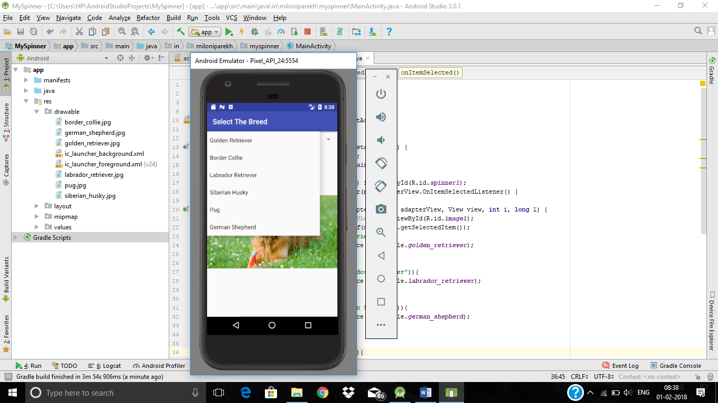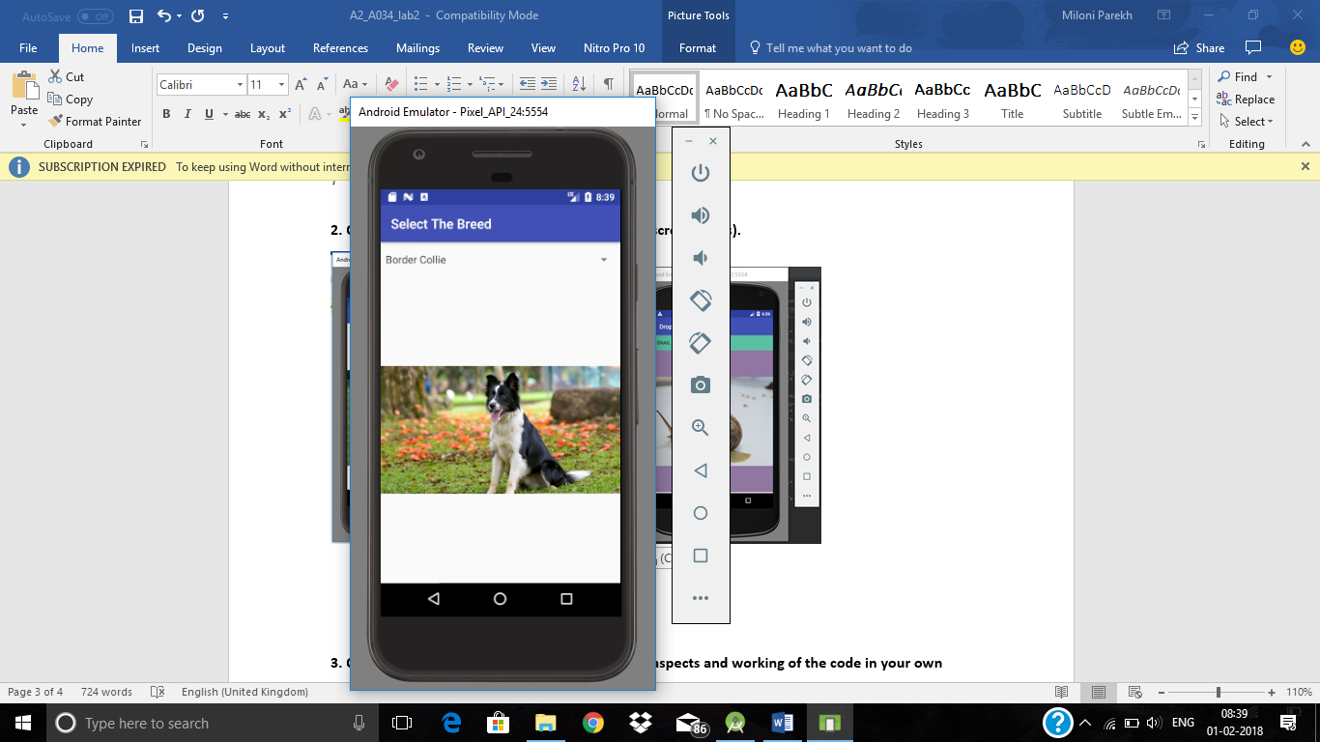

**Part B (to be completed by students)**

**(Students must submit the soft copy as per the following segments. The soft copy must be uploaded on the Blackboard. The filename should be Batch_RollNo_Exp_No)**

|  |  |
| --- | --- |
| **Roll No.:K033** | **Name:Rajpreet Singh Khurana** |
| **Sem:4th** | **Batch:K1** |
| **Date of Experiment:22-01-25** | **Date of Submission:** |

1. **Program Scenario and Program code:**

Activity_main.xml

<?xml version="1.0" encoding="utf-8"?>  
<androidx.constraintlayout.widget.ConstraintLayout xmlns:android="http://schemas.android.com/apk/res/android"  
 xmlns:app="http://schemas.android.com/apk/res-auto"  
 xmlns:tools="http://schemas.android.com/tools"  
 android:layout_width="match_parent"  
 android:layout_height="match_parent"  
 tools:context=".MainActivity">  
  
 <RelativeLayout  
 android:layout_width="match_parent"  
 android:layout_height="match_parent"  
 android:orientation="vertical">  
  
 <TextView  
 android:id="@+id/textView"  
 android:layout_width="match_parent"  
 android:layout_height="40dp"  
 android:text="Choose your meme!" />  
  
 <Spinner  
 android:layout_below="@id/textView"  
 android:id="@+id/spn_pic"  
 android:entries="@array/photo"  
 android:layout_width="match_parent"  
 android:layout_height="50dp" />  
  
 <ImageView  
 android:layout_below="@id/spn_pic"  
 android:id="@+id/img_pic"  
 android:scaleType="fitXY"  
 android:layout_width="fill_parent"  
 android:layout_height="fill_parent" />  
 </RelativeLayout>  
</androidx.constraintlayout.widget.ConstraintLayout>

**Strings.xml**

<resources>  
 <string name="app_name">Exp2_CyberSec</string>  
 <string-array name="photo">  
 <item>King Von</item>  
 <item>Kung fu Panda</item>  
 <item>Rick Roll</item>  
 <item>locked in Seong gi-hun</item>  
 <item>camel</item>  
 </string-array>  
</resources>

**Mainactivity.java**

package com.example.spinner;  
  
import android.os.Bundle;  
import android.view.View;  
import android.widget.AdapterView;  
import android.widget.ImageView;  
import android.widget.Spinner;  
import androidx.appcompat.app.AppCompatActivity;  
  
public class MainActivity extends AppCompatActivity {  
 Spinner spnpic;  
 ImageView imgpic;  
  
 @Override  
 protected void onCreate(Bundle savedInstanceState) {  
 super.onCreate(savedInstanceState);  
 setContentView(R.layout.*activity_main*);  
 spnpic = findViewById(R.id.*spn_pic*);  
 imgpic = findViewById(R.id.*img_pic*);  
 spnpic.setOnItemSelectedListener(new AdapterView.OnItemSelectedListener() {  
 @Override  
 public void onItemSelected(AdapterView<?> parent, View view, int i, long l) {  
 String choice = String.*valueOf*(spnpic.getSelectedItem());  
 if (choice.equals("King Von")) {  
 imgpic.setImageResource(R.drawable.*king_von*);  
 } else if (choice.equals("Rick Roll")) {  
 imgpic.setImageResource(R.drawable.*rick_roll*);  
 } else if (choice.equals("locked in Seong gi-hun")) {  
 imgpic.setImageResource(R.drawable.*squidgame*);  
 } else if (choice.equals("Kung fu Panda")) {  
 imgpic.setImageResource(R.drawable.*kung*);  
 } else if (choice.equals("camel")) {  
 imgpic.setImageResource(R.drawable.*camel*);  
 }  
 }  
 @Override  
 public void onNothingSelected(AdapterView<?> adapterView) {  
  
 }  
 });  
 }  
}

1. **Output:**

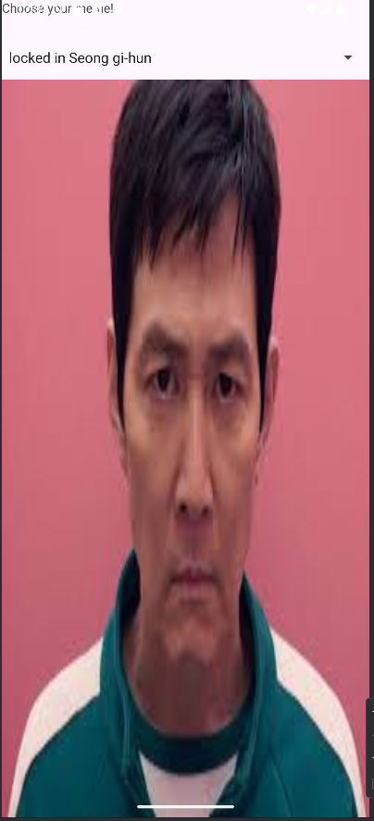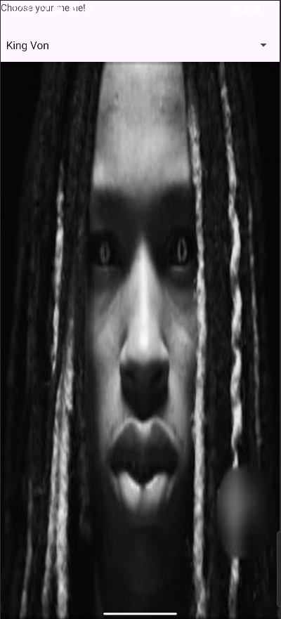

1. **Observations:** The emulator in my pc was not working. Besides that we added a spinner in the UI layout and in java file we used onItemsSelectedListener to display corresponding images of the list. We also made changes to strings.xml to add the text data in drop down menu.
2. **Questions: D**raw & Explain with respect to layouts the Scene Graph of the experiment.

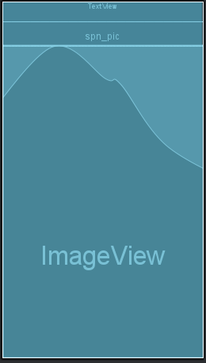

1. **Conclusion (Learning Outcomes)**

**We created an app that has a spinner to select options from it and display corresponding images, we used new library called AdapterView.**